WEEK 7

Mandatory Hands-On

**REACT**

**Creating a bloggerapp Application**

* *Bloggerapp* application is created in the directory Week7\ using the command *npx create-react-app Bloggerapp.*

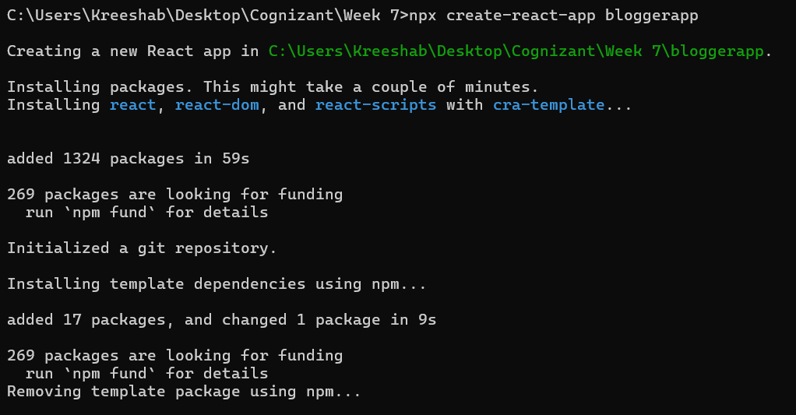

* Navigated to the React app and Created BlogDetails, BookDetails and CourseDetails components in components folder in src.

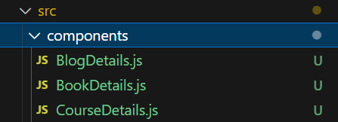

**BookDetails.js:**

import React from 'react';

function BookDetails() {

  return (

    <div style={{ padding: '0 20px' }}>

      <h2>Book Details</h2>

      <div>

        <h4>Master React</h4>

        <p>670</p>

      </div>

      <div>

        <h4>Deep Dive into Angular 11</h4>

        <p>800</p>

      </div>

      <div>

        <h4>Mongo Essentials</h4>

        <p>450</p>

      </div>

    </div>

  );

}

export default BookDetails;

**BlogDetails.js:**

import React from 'react';

function BlogDetails() {

  return (

    <div style={{ padding: '0 20px' }}>

      <h2>Blog Details</h2>

      <div>

        <h3>React Learning</h3>

        <p><b>Stephen Biz</b></p>

        <p>Welcome to learning React!</p>

      </div>

      <div>

        <h3>Installation</h3>

        <p><b>Schewzdenier</b></p>

        <p>You can install React from npm.</p>

      </div>

    </div>

  );

}

export default BlogDetails;

**CourseDetails.js:**

import React from 'react';

function CourseDetails() {

  return (

    <div style={{ padding: '0 20px' }}>

      <h2>Course Details</h2>

      <div>

        <h3>Angular</h3>

        <p>4/5/2021</p>

      </div>

      <div>

        <h3>React</h3>

        <p>6/3/20201</p>

      </div>

    </div>

  );

}

export default CourseDetails;

**App.js:**

import React, { useState } from 'react';

import BookDetails from './components/BookDetails';

import BlogDetails from './components/BlogDetails';

import CourseDetails from './components/CourseDetails';

function App() {

  return (

    <div style={{ padding: '20px' }}>

      <h1>Blogger App</h1>

      <div style={{ display: 'flex', justifyContent: 'space-around', borderLeft: '4px solid green', borderRight: '4px solid green' }}>

        <div style={{ borderRight: '4px solid green', padding: '0 20px' }}>

          <CourseDetails />

        </div>

        <div style={{ borderRight: '4px solid green', padding: '0 20px' }}>

          <BookDetails />

        </div>

        <div style={{ padding: '0 20px' }}>

          <BlogDetails />

        </div>

      </div>

    </div>

  );

}

export default App;

**Sample Output:**

